US Senate Committee on Health, Education, Labor & Pensions

Re: Hearing on “Vaccines Save Lives: What is Driving Preventable Disease Outbreaks?”

Dear Senators,

It is imperative that state exemptions to vaccination remain free from federal influence and incentive. I am writing to provide the Health Committee with facts that are at risk of being omitted from medical industry and government public health employee testimony.

My hope is that each of you will use the points I raise in this letter to ask pointed questions of, and elicit honest answers from, your witnesses in order to help you understand the true driving force of preventable disease outbreaks. Operating on the assumption that this hearing will focus exclusively on continuing outbreaks of measles, mumps, whooping cough and chickenpox, I will likewise focus on those diseases.

Parents who make use of their state’s religious and personal vaccine exemptions were under an avalanche of negative attention, with FDA Commissioner Scott Gottlieb hinting at Federal involvement in reducing state exemptions. In addition, there was Representative Adam Schiff’s request for Facebook to remove vaccination information groups from its suggested groups function, Pinterest removed the word “vaccine” from its search function, and YouTube removed the ability to monetize any video that is critical of vaccines or the vaccination schedule. These moves are in addition to current state-level bills to remove religious and personal vaccine exemptions in New York, New Jersey, Maine, Vermont, Minnesota, Iowa, Arizona, Washington, Oregon, and possibly Colorado. One has to wonder what deadline has triggered this flurry of activity in 2019.

While it would be easy to pin this urgency on the recent measles outbreaks of 64 cases in a Ukrainian immigrant community in Clark County, Washington (zero deaths, one hospitalization), and 138 cases in an Ultra-Orthodox Jewish community in Rockland County, New York (zero deaths, “more than one” hospitalization according to media reports), the fact that measles outbreaks predictably peak in three-to-four-year cycles, as shown by this graph created by the CDC, cannot be the true reason for our current state of mass hysteria.

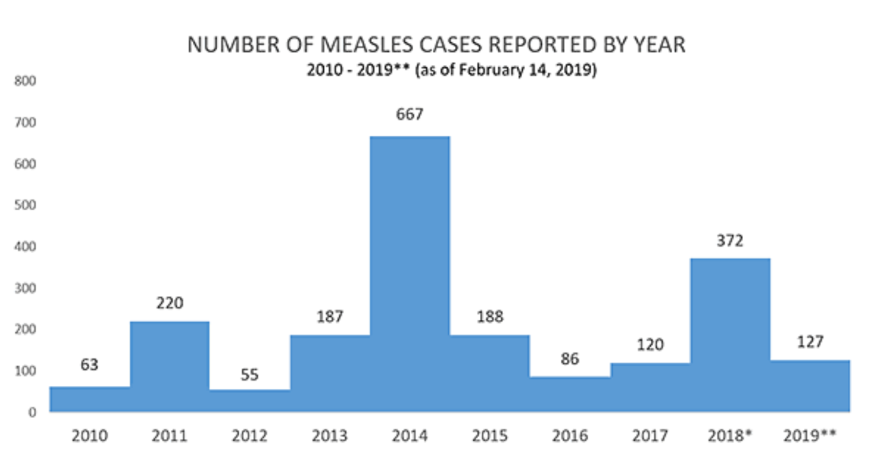
Before your committee recommends a program to entice state legislations to pass laws eliminating religious and personal vaccine exemptions, it is vitally important that it considers the facts behind vaccination rates and disease outbreaks for the past decade.

Healthy People 2020: US Already Has 95% Measles/Mumps Vaccination Kindergarten Rate

As in the previous decade, the US Department of Health and Human Services’ Office of Disease Prevention and Health Promotion has promulgated a program by the name of Healthy People. Healthy People 2020’s objectives can be found on their healthypeople.gov website, which provides data on their “Immunization and Infectious Disease” objectives.

The following chart, comprised of data from Healthy People as well as the Centers for Disease Prevention and Control, displays the rate of pediatric MMR vaccine uptake for both one dose and two, where data is available, alongside the incidence of measles and mumps for the corresponding years.

When viewed this way, our public health sector’s own data tells the story of how alleged decreasing vaccination rates, or increasing use of vaccine exemptions, are not a factor in the varying levels of measles and mumps outbreaks. For the years reported below, the percentage of toddlers receiving the first dose of MMR before age three has never wavered below 90% or above 92.1%. Likewise, the percentage of kindergarteners receiving the second dose of MMR has never wavered below 94.7% or above 95%. Yet, measles and mumps outbreaks have varied wildly.

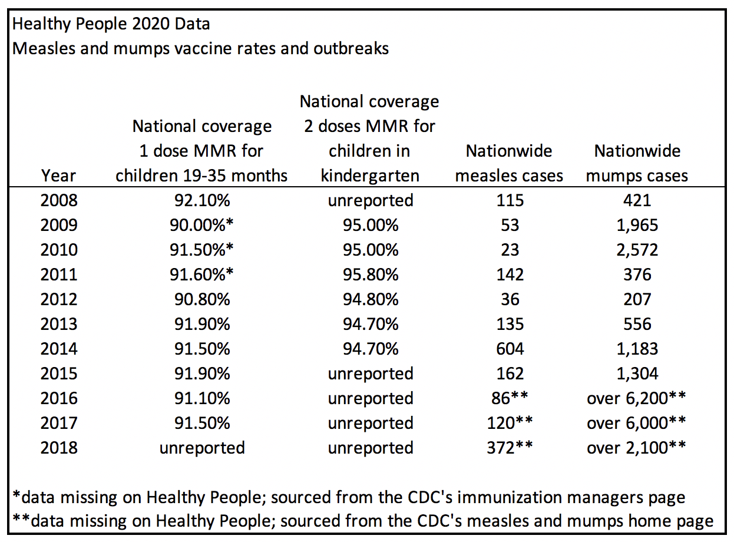

If one accepts the theory that measles and mumps herd immunity relies on 95% of children receiving two doses of the MMR vaccine, our trends show that the US has continuously achieved that compliance for at least as decade.

This finding should motivate the committee to investigate alternative reasons for measles and mumps outbreaks, along with alternative measures for controlling disease, that do not involve stripping parents of their rights to make medical decisions for their children.

How the US Compares to Europe, Japan and Singapore

America is the third most populous nation yet we have one of the lowest rates of measles in the world. With only 372 cases of measles in 2018 across the population of 326 million, America most recently had 1.1 cases of measles per million people. According to the European Centre for Disease Prevention and Control, during the months of June 2017 to May 2018, that is a far lower rate of measles infection per capita than any country in Europe excluding Denmark, Lithuania, Malta and the Netherlands. In fact, our measles rate was half that of Japan, which reported 287 cases in 2018, or 2.2 cases per million people. Yet it doesn’t appear that Japan, or any of the Scandinavian nations, is rushing to join our measles hysteria and convert their entirely voluntary vaccination programs to mandatory ones.

Interestingly, Singapore eliminated measles in 2018 with a two-dose MMR uptake rate of only 88% for 2016 and 90% for 2017 (source: WHO-UNICEF Immunization Coverage 2018 Global Summary). Simultaneously, Singapore was the number one travel destination in the world for tourists, many of whom are Asian and Middle Easterners who are likely not vaccinated for measles. One has to wonder what dietary and environmental factors are also to credit for Singapore’s ability to eliminate measles while being well under the US’ claim of needing at least 95% of a population to be vaccinated with two doses of MMR.

Are the Outbreaks Comprised of Unvaccinated Children?

While the newest Clark County, WA and Rockland County, NY measles outbreaks are in, and contained to, ethnic and religious communities that have opted not to vaccinate their children, other measles outbreaks have been a mix of vaccinated and unvaccinated people.

According to the California Department of Health Immunization Branch, of the 131 Californians involved in the 2014-2015 measles outbreak at Disneyland, 49 were adults who both self-reported being vaccinated and responded “I don’t know” when asked about their vaccination status. Another 25 people were able to confirm vaccination through records, and 57 reported they were unvaccinated. Of the 25 who produced records (likely these are children due to record accessibility), 10 had one dose of the MMR, 14 had two doses, and 2 had three doses.

If one to three doses of MMR can result in a measles infection upon exposure in a child or young adult, our health authorities should be prompted to investigate vaccine waning, vaccine failure to produce antibodies, and dietary and environmental factors that result in infection. Endorsing the idea of more vaccines as a solution is misguided and unfounded.

After one dose of MMR, 7% of children will not develop measles immunity (source: CDC measles home page). Our second dose of kindergarten MMR was not added to the vaccination schedule until 1989. This means that Americans who were born after 1957, the cutoff of when the CDC presumes natural immunity from infection, but before 1985, have received only one dose of measles vaccine. This group is currently aged 34 to 62 and comprises almost one-third of the US population. If 7% of the single MMR group were non-responders to the measles vaccine, they total more than seven million people.

Further, research shows that 13 to 15 years after vaccinating children with two doses of MMR, only 75% retained effective quantities of measles antibodies by the time they were teenagers. (Source: Persistence of Measles, Mumps, and Rubella Antibodies in an MMR-Vaccinated Cohort: A 20-Year Follow-up). This number is 20 points below experts’ claim of needing 95% vaccination rates for measles herd immunity.

Clearly, with the issue of measles vaccines waning a decade after two doses, compounded by a significant number of measles vaccine non-responders, a true 95% rate of measles immunity is mathematically impossible to attain without continuous re-vaccination of the American public.

Mumps Vaccine Efficacy: Fraudulent Misrepresentation to the FDA

The mumps outbreaks in highly vaccinated populations over the last decade are especially interesting. According to the Arkansas Health Department, where thousands of mumps cases were diagnosed in 2016-2017, there is evidence that the outbreaks are not due to vaccine waning. The health department explained that in the event of a waning vaccine, they would expect to find very few mumps infections in people who were vaccinated in recent years, with most cases appearing in those who are several years out from their last MMR vaccine. However, the equal distribution of mumps infections across a wide age range of highly vaccinated people in Arkansas indicates that vaccine waning is not to blame. This should be interpreted to mean that there is a problem with the mumps vaccine efficacy at the time of vaccine administration, which correlates with the claims in ongoing litigation against Merck.

If it hasn’t already, this committee must investigate the allegations of the two qui tam lawsuits in the eastern district of Pennsylvania: U.S. v. Merck (case number 2:10-c-v-04374) and Chatom v. Merck (case number 2:12-cv-03555). These cases stem from two former Merck virologists who allege that Merck used falsified test results to fraudulently overstate the efficacy of the mumps component of their MMR vaccine to the FDA. In other words, the issue isn’t that Merck’s mumps vaccine wanes. The problem is that since at least 1999, the vaccine was nowhere near as effective as Merck represented to regulators.

Seen through this lens, it is obvious that even our 95% two-dose uptake of MMR has resulted in thousands of mumps infections in highly vaccinated populations. Influencing state legislators to remove vaccine exemptions will have no impact on Merck’s mumps vaccine failure or on curbing these outbreaks in our nation.

Healthy People 2020: Whooping Cough Vaccine Failure and Medical Malpractice

3 to 16 infants under one year old have died of whooping cough (pertussis) infection each year since 2012. While that is an extraordinarily small number, these deaths are, understandably, an extremely emotional issue. Using Healthy People’s data for the years reported below, compliance rates of toddlers receiving four doses of the whooping cough DTaP vaccine have never dropped below 82.5% and have never risen above 84.6%. The compliance rate of children receiving those four doses before entering kindergarten is even higher, at 95.2% to 97.2% for the years reported. Yet, the average whooping cough infection rates of children under one year old in the those time periods has risen 47%. Additionally, the infection rate of 11 to 18-year-olds has risen 66%, despite the near-90% of teens who now receive a 5th dose of a pertussis-containing vaccine.

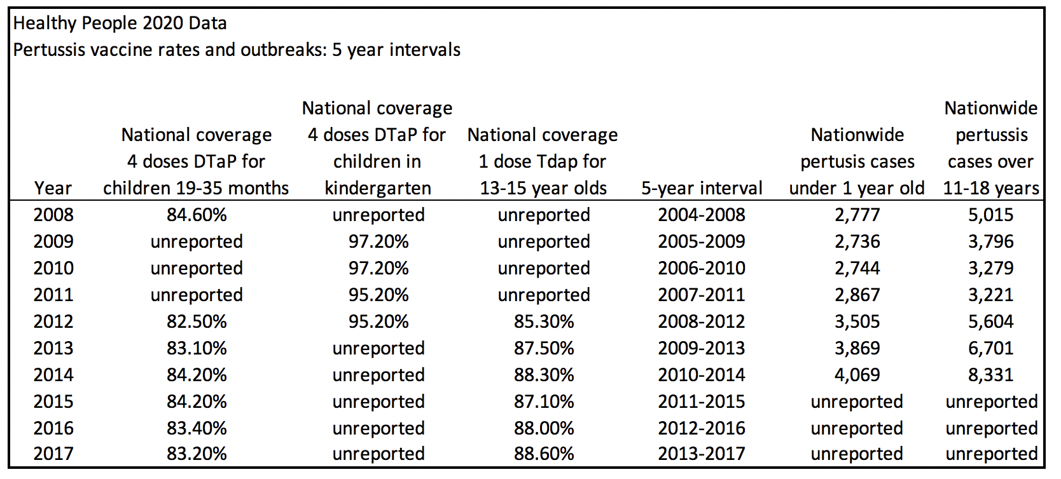

It needs to be pointed out that in November, 2013, the FDA announced that the acellular pertussis component used in the DTaP and Tdap vaccines “fails to prevent colonization or transmission” of whooping cough infection in primates. The whooping cough vaccine is effective at reducing whooping cough symptoms in the vaccinated person if received in the past year. However, our FDA has stated that it cannot prevent a whooping cough infection from forming in the vaccinated person, which is contagious to other people. There is always a risk that an asymptomatic carrier of whooping cough infection can transmit the disease to an infant who is too young for the DTaP vaccine. (See Acellular pertussis vaccines protect against disease but fail to prevent infection and transmission in nonhuman primate model, US Food and Drug Administration, January 2014)

Before this committee concludes that America should return to the pre-1999 whole-cell version of the pertussis vaccine, it should be noted that an Israeli study of 46 fully DPT-vaccinated children also concluded that “[whole cell] vaccinated children may be asymptomatic reservoirs for infection.” (See Pertussis infection in fully vaccinated children in daycare centers, Israel, September 2000)

In addition to the failure to prevent infection and transmission, Kaiser Permanente released a 2016 study detailing the extreme waning problems with the Tdap vaccine in teenagers. Kaiser concluded, “Routine Tdap did not prevent pertussis outbreaks. Among adolescents who have only received DTaP vaccines in childhood, Tdap provided moderate protection during the first year and then waned rapidly so that little protection remained 2 to 3 years after vaccination.” (See Waning Tdap Effectiveness in Adolescents, Kaiser Permanente, Bnai Zion Medical Center, March 2016)

Sadly, there is a near-unreported problem compounding our pertussis vaccine failures. An LA Times investigation revealed that, up to the date of the article publication, all eight California infants who died from pertussis in 2010 were repeatedly misdiagnosed by doctors and denied life-saving medical care. (See Diagnoses lagged in baby deaths, LA Times September 7, 2010)

In summary, “herd immunity” to pertussis infection is not an attainable goal through vaccination. This committee should consider directing health departments and medical care providers to make pertussis diagnosis more quickly, encourage home quarantine, and to permanently halt the practice of assuming vaccinated children cannot become sick with pertussis.

Healthy People 2020: Chickenpox Vaccine Effect Has Hit Its Max

Question: “Why aren’t children in the UK vaccinated against chickenpox?”

Answer: The chickenpox vaccine is not part of the routine UK childhood vaccination programme because chickenpox is usually a mild illness, particularly in children. There’s also worry that introducing chickenpox vaccination for all children could increase the risk of chickenpox and shingles in adults.” – “Common Questions” web page, National Health Service, United Kingdom

Indeed, removing the prevalence of chickenpox in our society has resulted in an annual epidemic of one million cases of shingles infection each year.

However, since we do require this vaccine for school, we should examine its efficacy. In the chart on the following page, we see from Healthy People 2020 data that in the years reported, the trend in US vaccination rates against chickenpox in kindergarteners is very high, consistently within a narrow window falling between 91.3% and 93.3%. Yet chickenpox infections have varied wildly, from a low of 145,000 cases to a high of 586,000.

Aside from asking why we vaccinate for chickenpox when many other developed nations do not, and from inquiring why we continue to suffer with shingles epidemics as the cost of our chickenpox vaccination program, it is clear that consistently high vaccination rates are no longer impacting the number of chickenpox outbreaks in recent years. Removing parental exemptions to the chickenpox vaccine would prove to be a failure in curbing the disease any further.
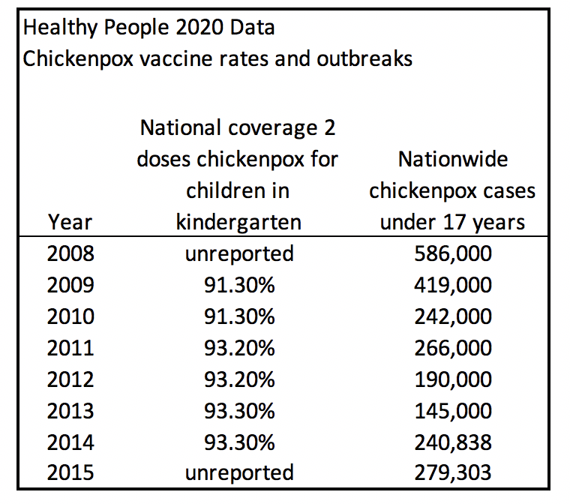

In Closing: Removing Vaccine Exemptions Cannot Reduce Disease

While it is understandable that HHS may be disappointed with the outcomes documented by their Healthy People 2020 program, parents who opt to use state exemptions to vaccination are undeserving of the recent blitz to remove their state-given rights. As shown throughout this letter, removing the right to exemptions will not bring about the decrease in disease prevalence sought by Healthy People 2020.

Vaccines are a manmade product complete with human shortcomings. It is these laboratory deficiencies that are the driving force behind the continued outbreaks of so-called vaccine-preventable disease. We should now turn our attention to nutrition and environmental factors behind preventing disease, hold vaccine manufacturers accountable for misrepresenting products to federal regulators, and leave the option to exercise vaccine exemptions with parents.

Sincerely,

