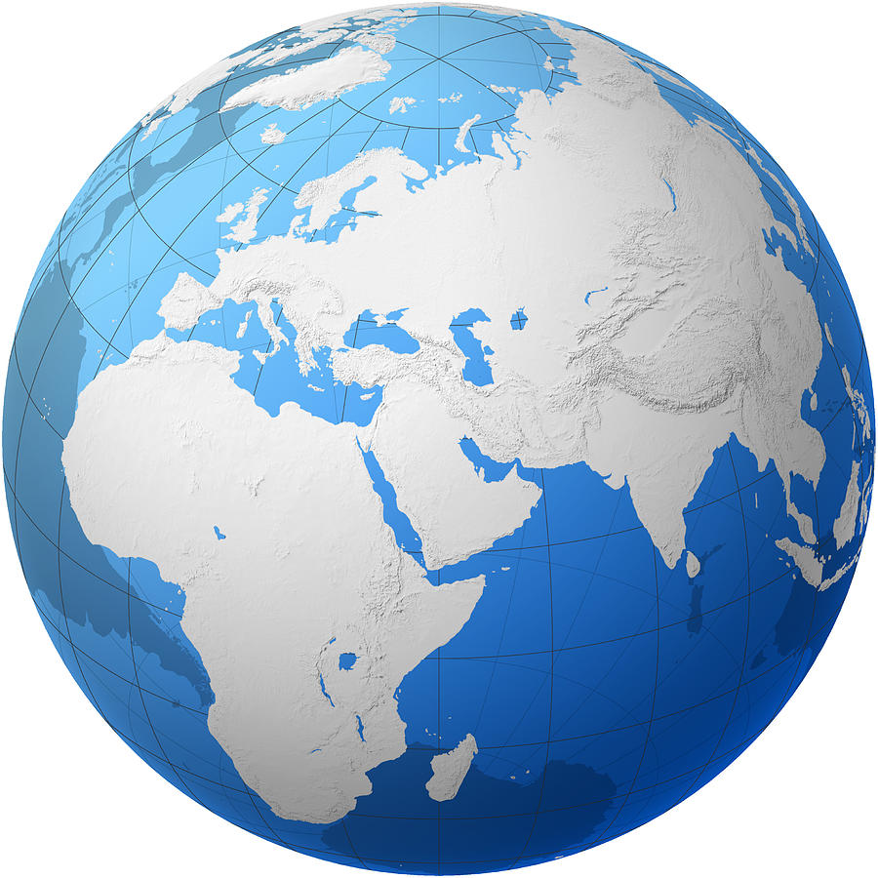
THE WORLD-WIDE MOVEMENT
AGAINST WATER FLUORIDATION

In stark contrast to the Center for Disease Control’s claim that fluoridation is one of the top ten public health achievements of the 20th century, it is one of the most widely rejected health interventions in the world.
Out of 196 nations, only 24 have any fluoridation, and only 10, like the U.S., for more than half their population. Over 95% of the world’s population is fluoridation-free. The U.S. fluoridates as many people as the rest of the world combined.

None of the largest Asian nations, including China, India and Japan, fluoridate. Out of 54 countries in Africa, only one fluoridates – Libya, and only for a small percent of its population. In Europe, only four out of 48 countries fluoridate (less than 2% of the population). A few have fluoridated salt, but only as a consumer choice.

France, Germany, Belgium, the Netherlands, Denmark, Norway and Sweden have all prohibited fluoridation, many citing the ethical problem of putting any drug in drinking water.
For dozens of nations that haven’t banned it, thousands of major cities and smaller towns don’t fluoridate, including Athens, Barcelona, Budapest, Geneva, Helsinki, London, Madrid, Prague, Rome, Vienna and Warsaw. Ireland is the only European nation mandating fluoridation. But despite the mandate, 13 town and county councils, including Dublin and Cork, have voted for its immediate cessation.

Many organizations still support fluoridation, but those opposing it grows year by year. They include:

• American Academy of Environmental Medicine • Center for Health, Environment and Justice
• Children’s Health Defense • Eau Secours (Canadian coalition of 234 groups promoting clean, safe water)
• Council of Canadians • Environmental Working Group • Food and Water Watch
* Institute of Neurotoxicology & Neurological Disorders • International Academy of Biological Dentistry and Medicine
• International Academy of Oral Medicine and Toxicology • League of United Latin American Citizens
• Moms Against Fluoridation • Organic Consumers Association

In addition, many organizations once endorsing fluoridation have pulled back, no longer taking a position. They include the Alzheimer’s Association, American Academy of Allergy, Asthma and Immunology, Center for Science in the Public Interest, Consumers Union (Consumer Reports), National Association of Social Workers, National Down Syndrome Congress, National Down Syndrome Society and National Kidney Foundation.

The trend is clear. And as the scientific data accumulate, more and more nations, cities and organizations are challenging the safety, efficacy, costs and ethics of fluoridation.

